# Peak Detection Algorithm for LCD display

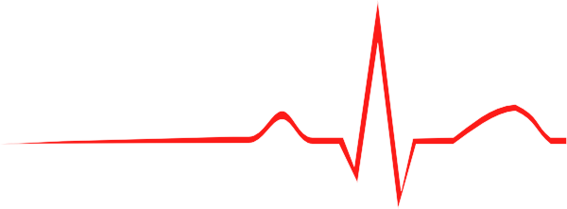

Threshold

A

B

C

Figure _: BitPulse heart rate algorithm. Image from : <http://www.clker.com/clipart-ecg-long.html>

Upon receiving the ECG signal the sketch stores the values into three variables. The C variable is the current value received while B is the previous stored value. The A variable is the value two instances before C. When the B value is above the threshold and when B value is higher than C and A, the heart beat is recorded. A and B resets back to zero to prevent multiple counting of peaks. The threshold is set to 600.

# Heart rate monitoring and status update

Yes

Yes

No

No

No

Start

Incoming ECG data stored in array

Array has more than 315 variables?

Yes, restart array from first variable

Peak detection and HR stored in memory

Timer = 10 Seconds?

In array

No

Yes

Multiply HR by 6

In array

HR higher than 100 BPM ?

Display value to LCD

Update status on LCD

HR lesser than 60 BPM ?

HR is within 60 to 100 BPM ?

Yes

Graph values to LCD

Reset timer to 0

Reset HR to 0

Figure _: BitPulse LCD display algorithm

The full code to calculate and display the heartbeat can be found in the Appendix 1a. Pin A5 is set to receive the analog signal from the ECG. The heart rate is calculated by multiplying the number of peaks detected every 10s with 6. The graph on the LCD plots every 35ms while the status and heartbeat are updated every 10s. The values for the graph are stored in an array with 315 values

Appendix 1A: LCD_codes.ino

